Steps to setup HDP search:

1. Download the Ambari management pack to the Ambari Server host.

**cd /tmp**

**wget** <http://public-repo-1.hortonworks.com/HDP-SOLR/hdp-solr-ambari-mp/solr-service-mpack-5.5.2.2.5.tar.gz>

1. Install the management pack on the Ambari Server host, using the following command:

**ambari-server install-mpack --mpack=/tmp/solr-service-mpack-5.5.2.2.5.tar.gz**

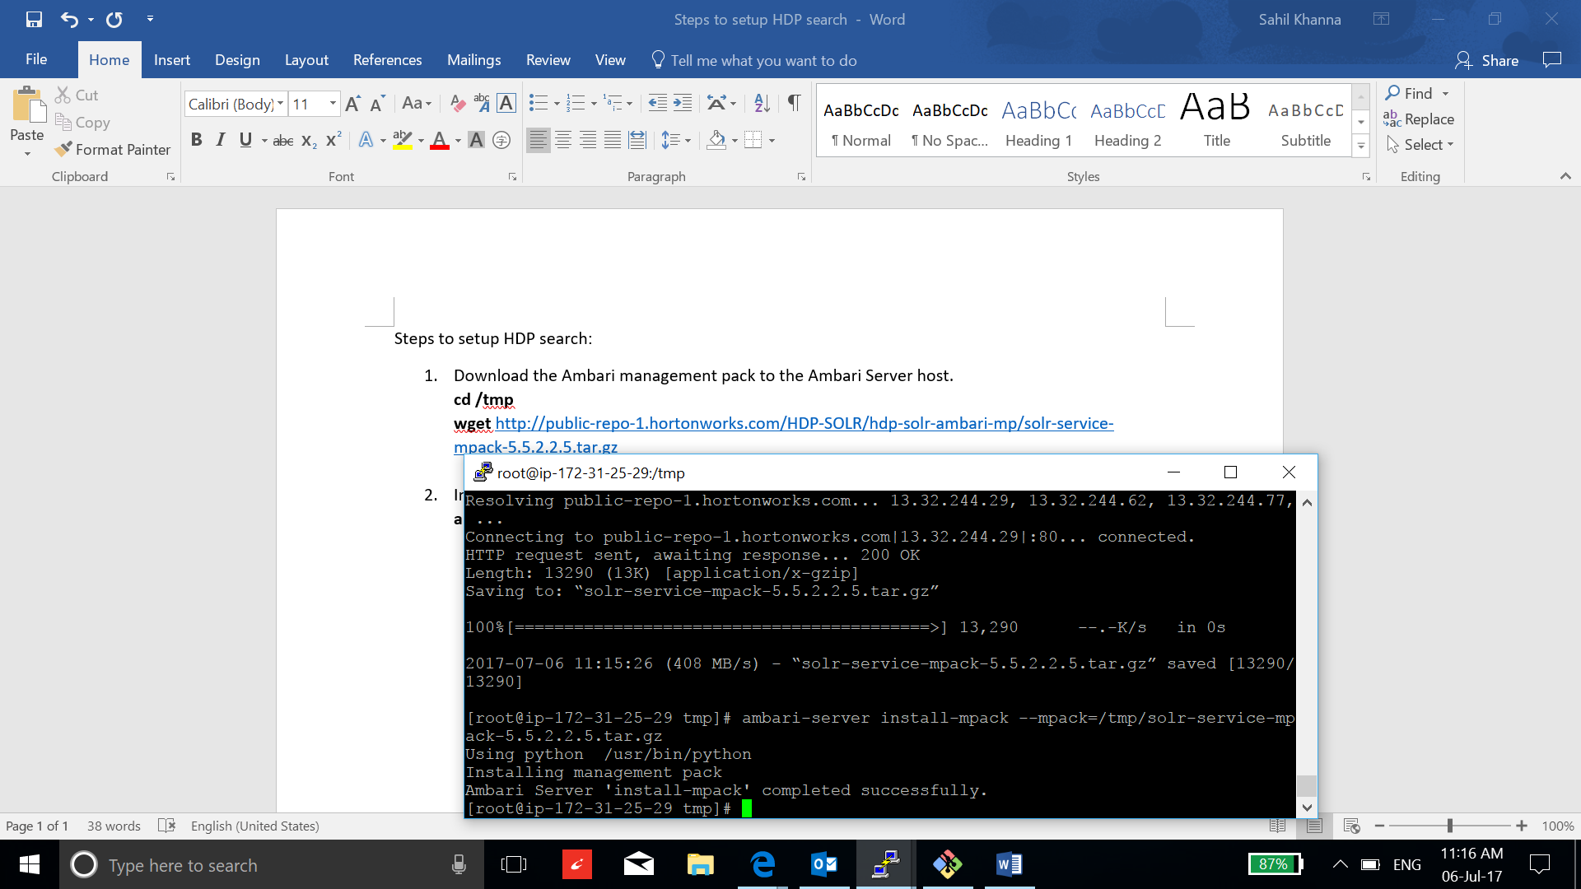

1. Edit the file: /var/lib/ambari-server/resources/stacks/HDP/2.6/repos/repoinfo.xml, add the HDP-SOLR-2.5-100: <http://public-repo-1.hortonworks.com/HDP-SOLR-2.5-100/repos/centos6>

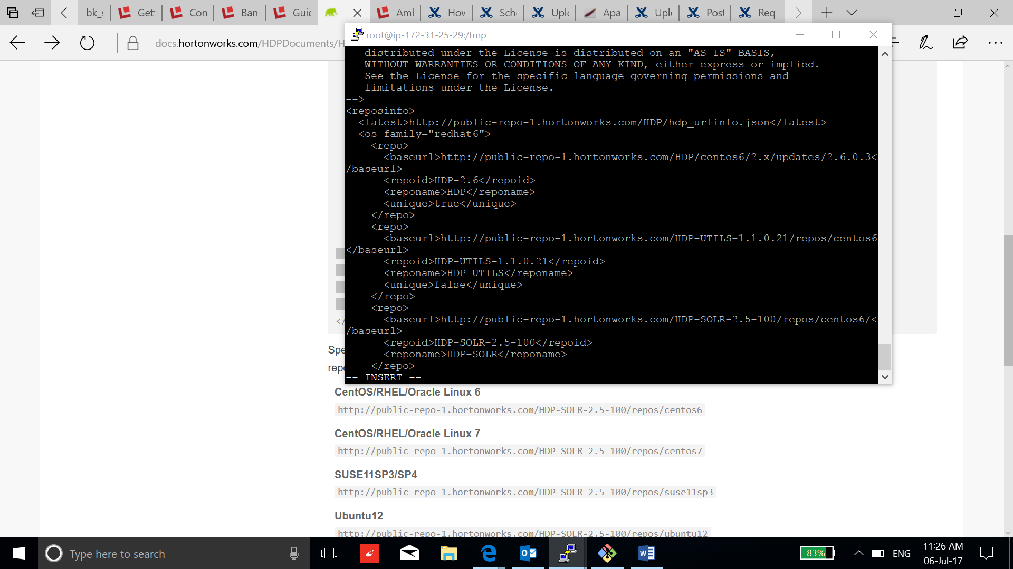

1. Restart the Ambari Server, to recognize the new repository and the management pack:

**ambari-server restart**

1. Now go to the Ambari and select add service to add solr:

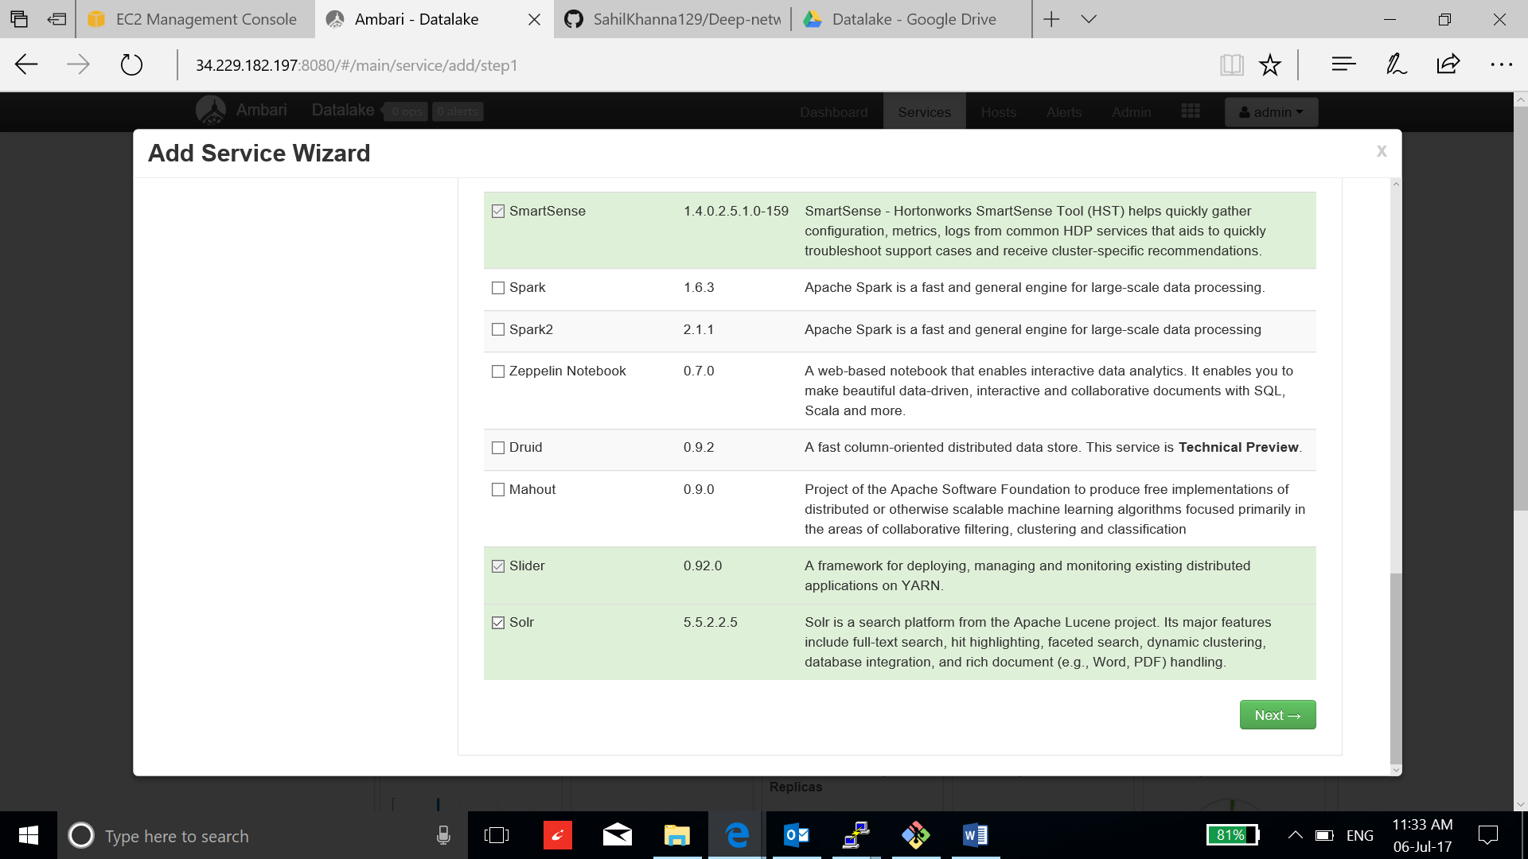

1. Appoint Solr master to the instance and click next:

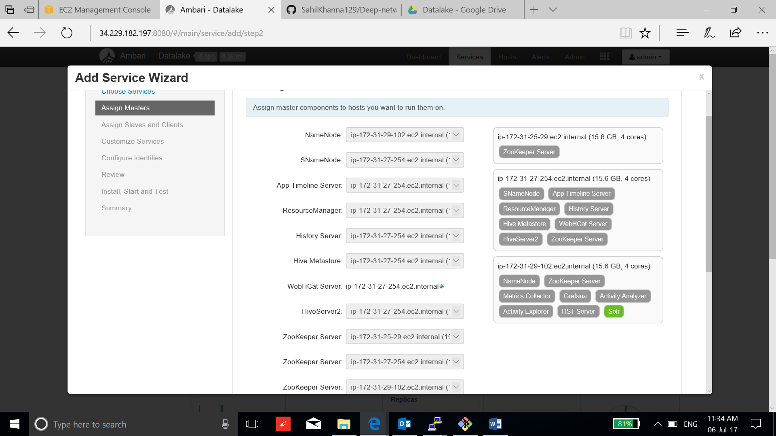

1. Keep the default configuration and click next:

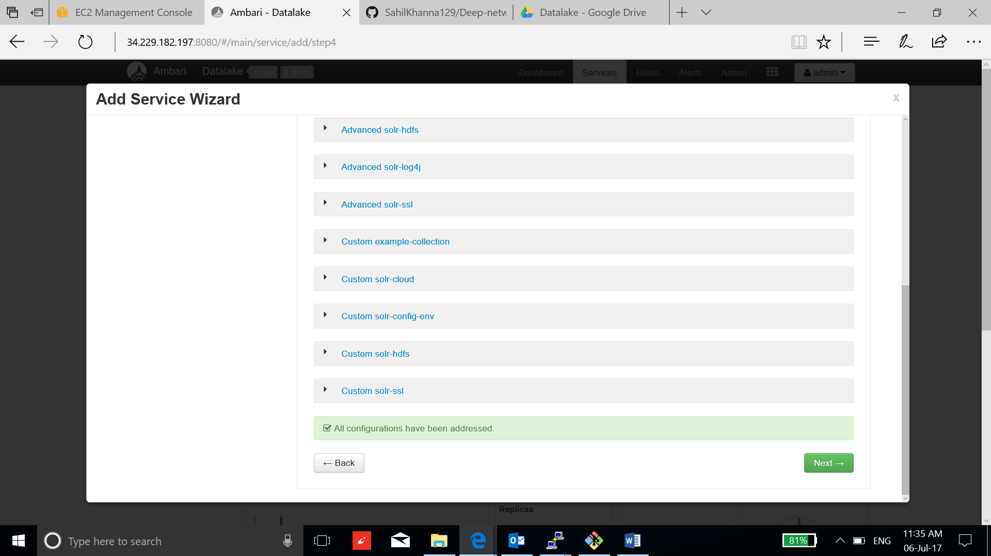

1. Review and click deploy:

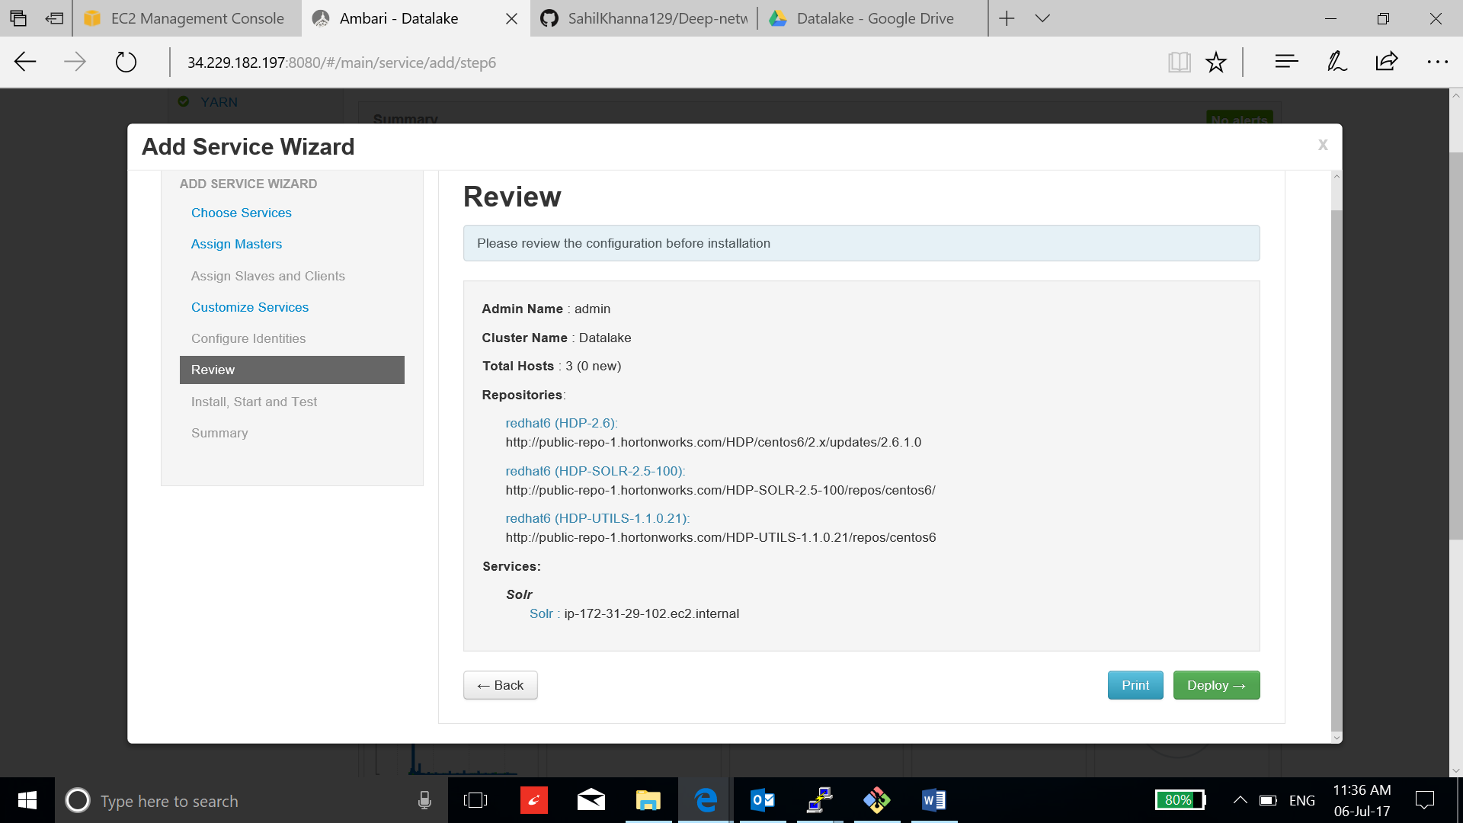

1. After the installation is complete, click next and complete the process:

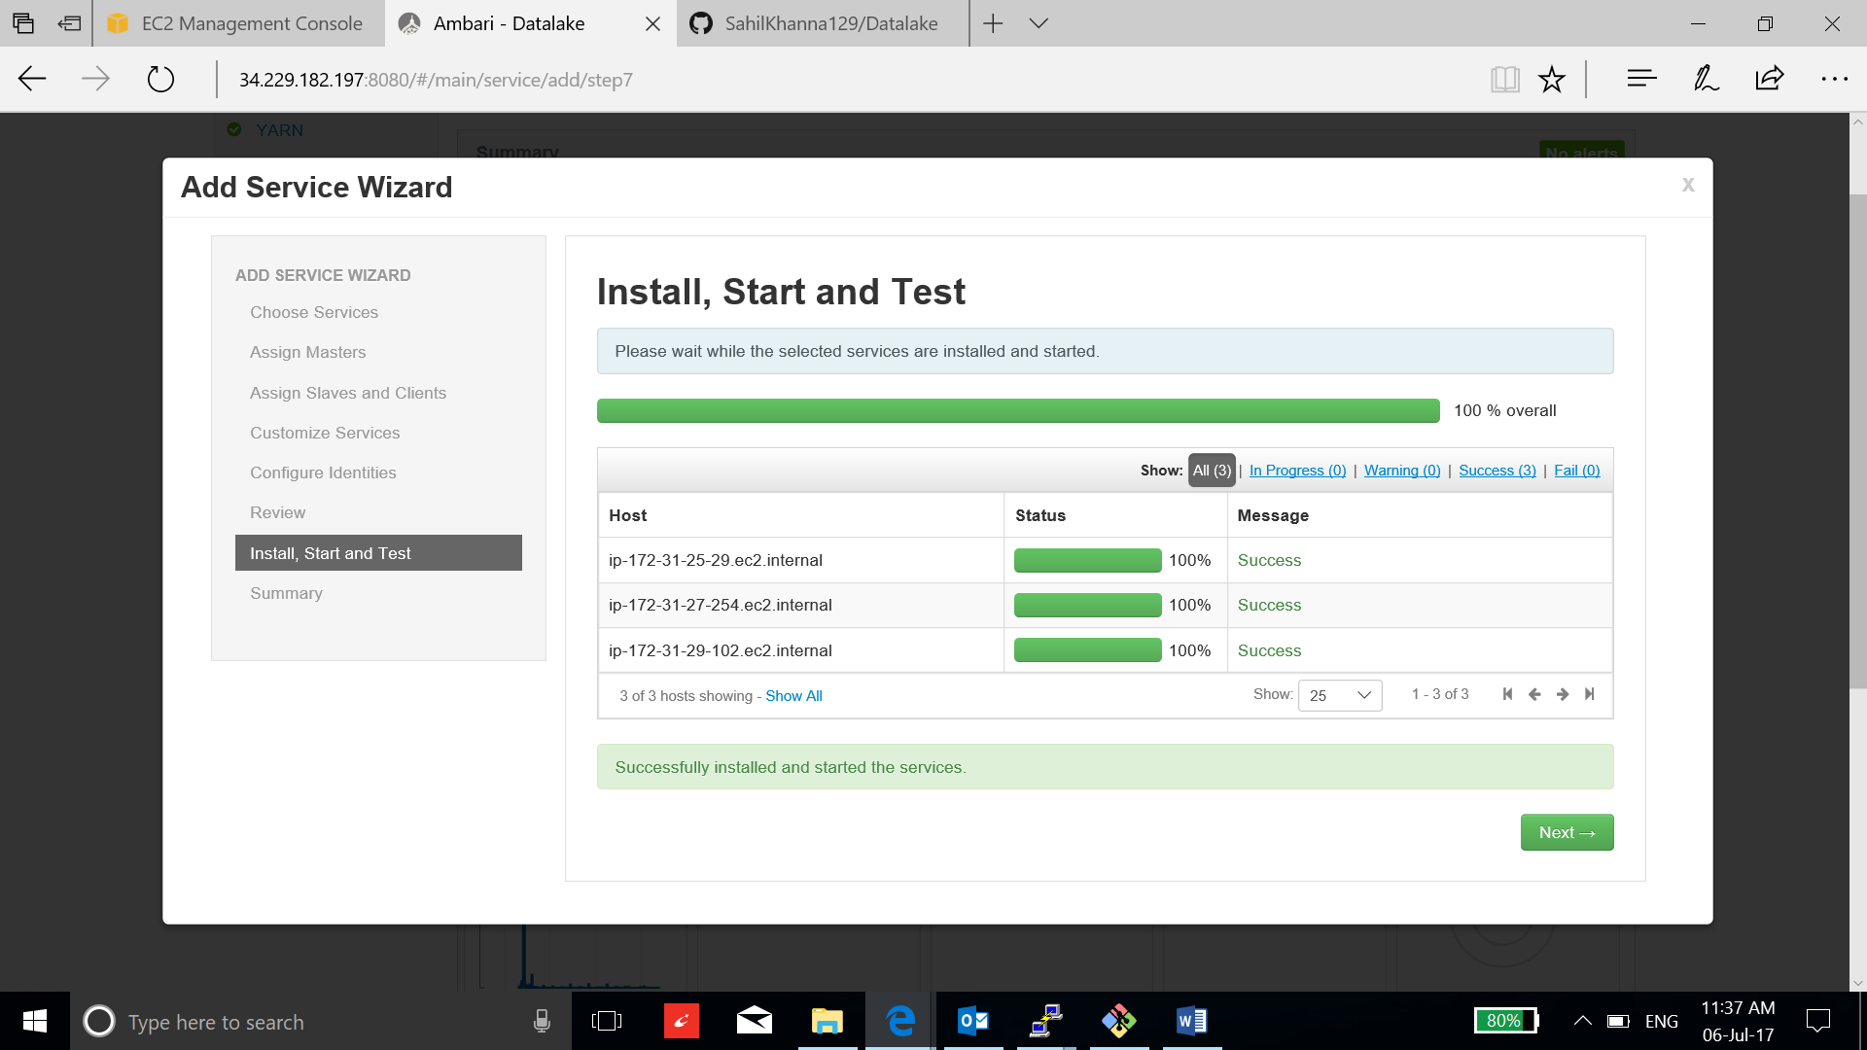

1. Go to Solr dashboard to check the installation:

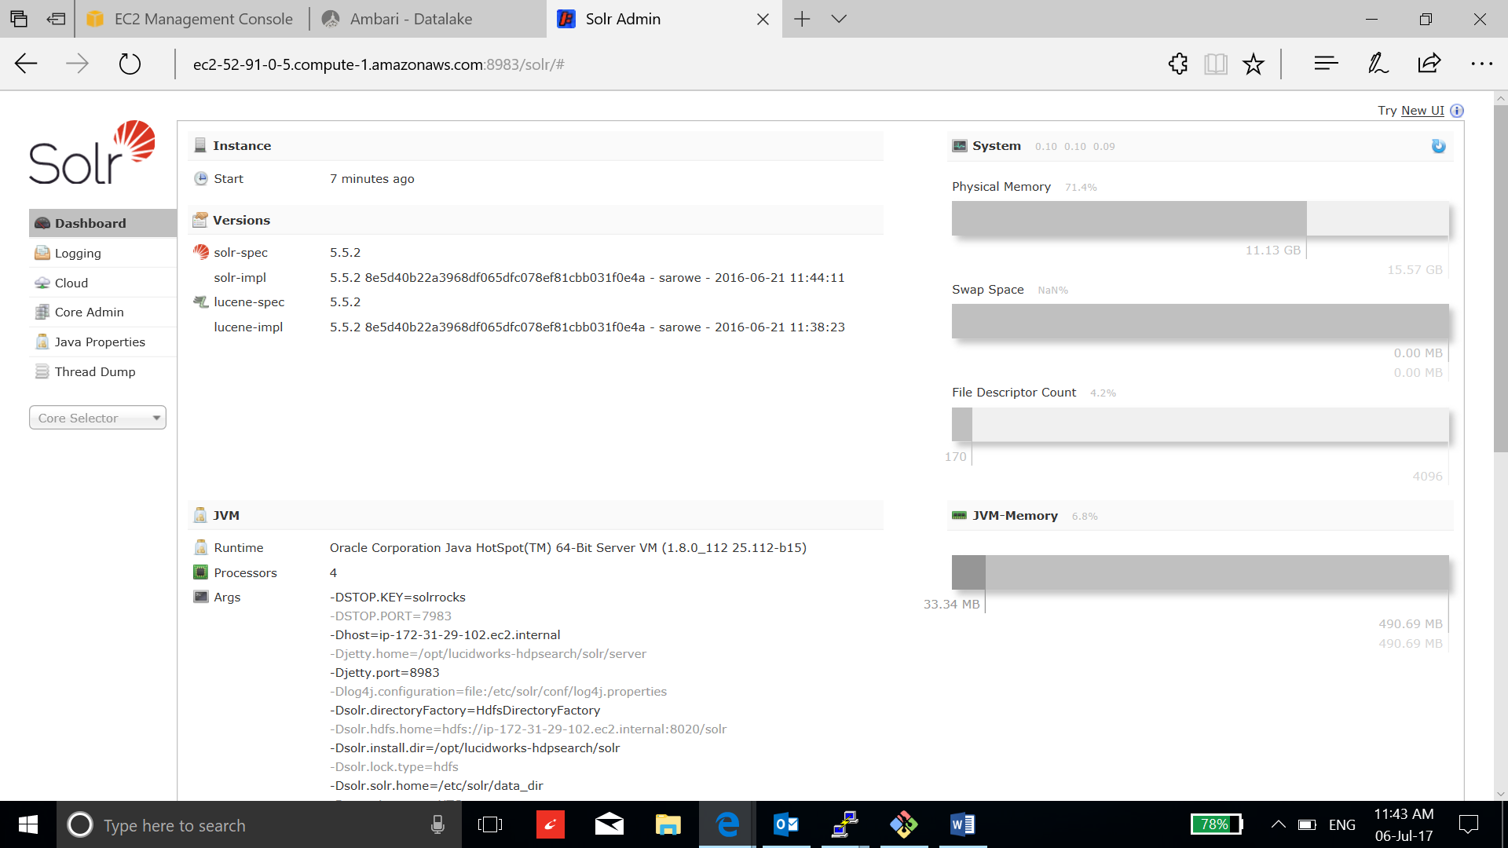

1. Use Solr on the sample data provided with the installation to get started, go to the /opt/lucidworks-hdpsearch/solr/ directory in the Solr host and create a core “files”:

**bin/solr create -c files -d example/files/conf**

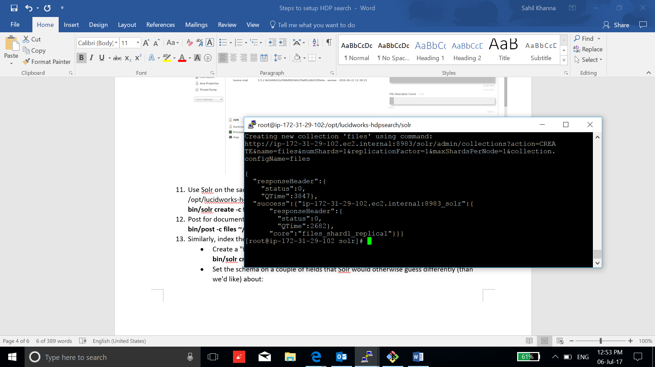

1. Create a text file and post documents into the core for indexing:

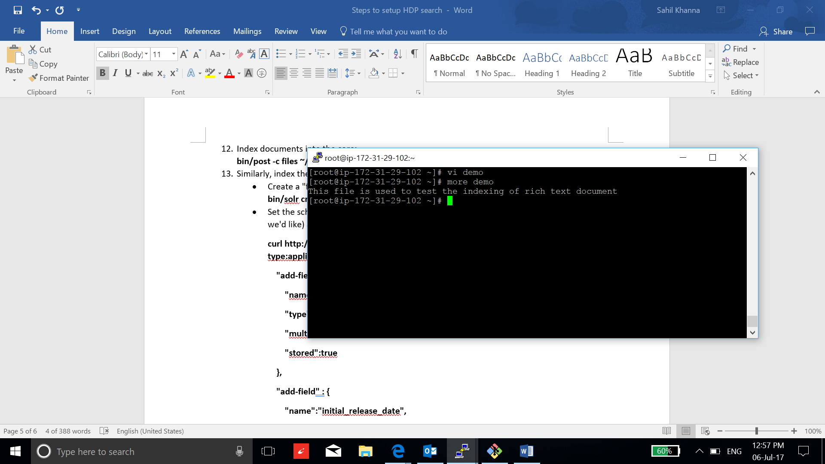

**bin/post -c files /root/demo**

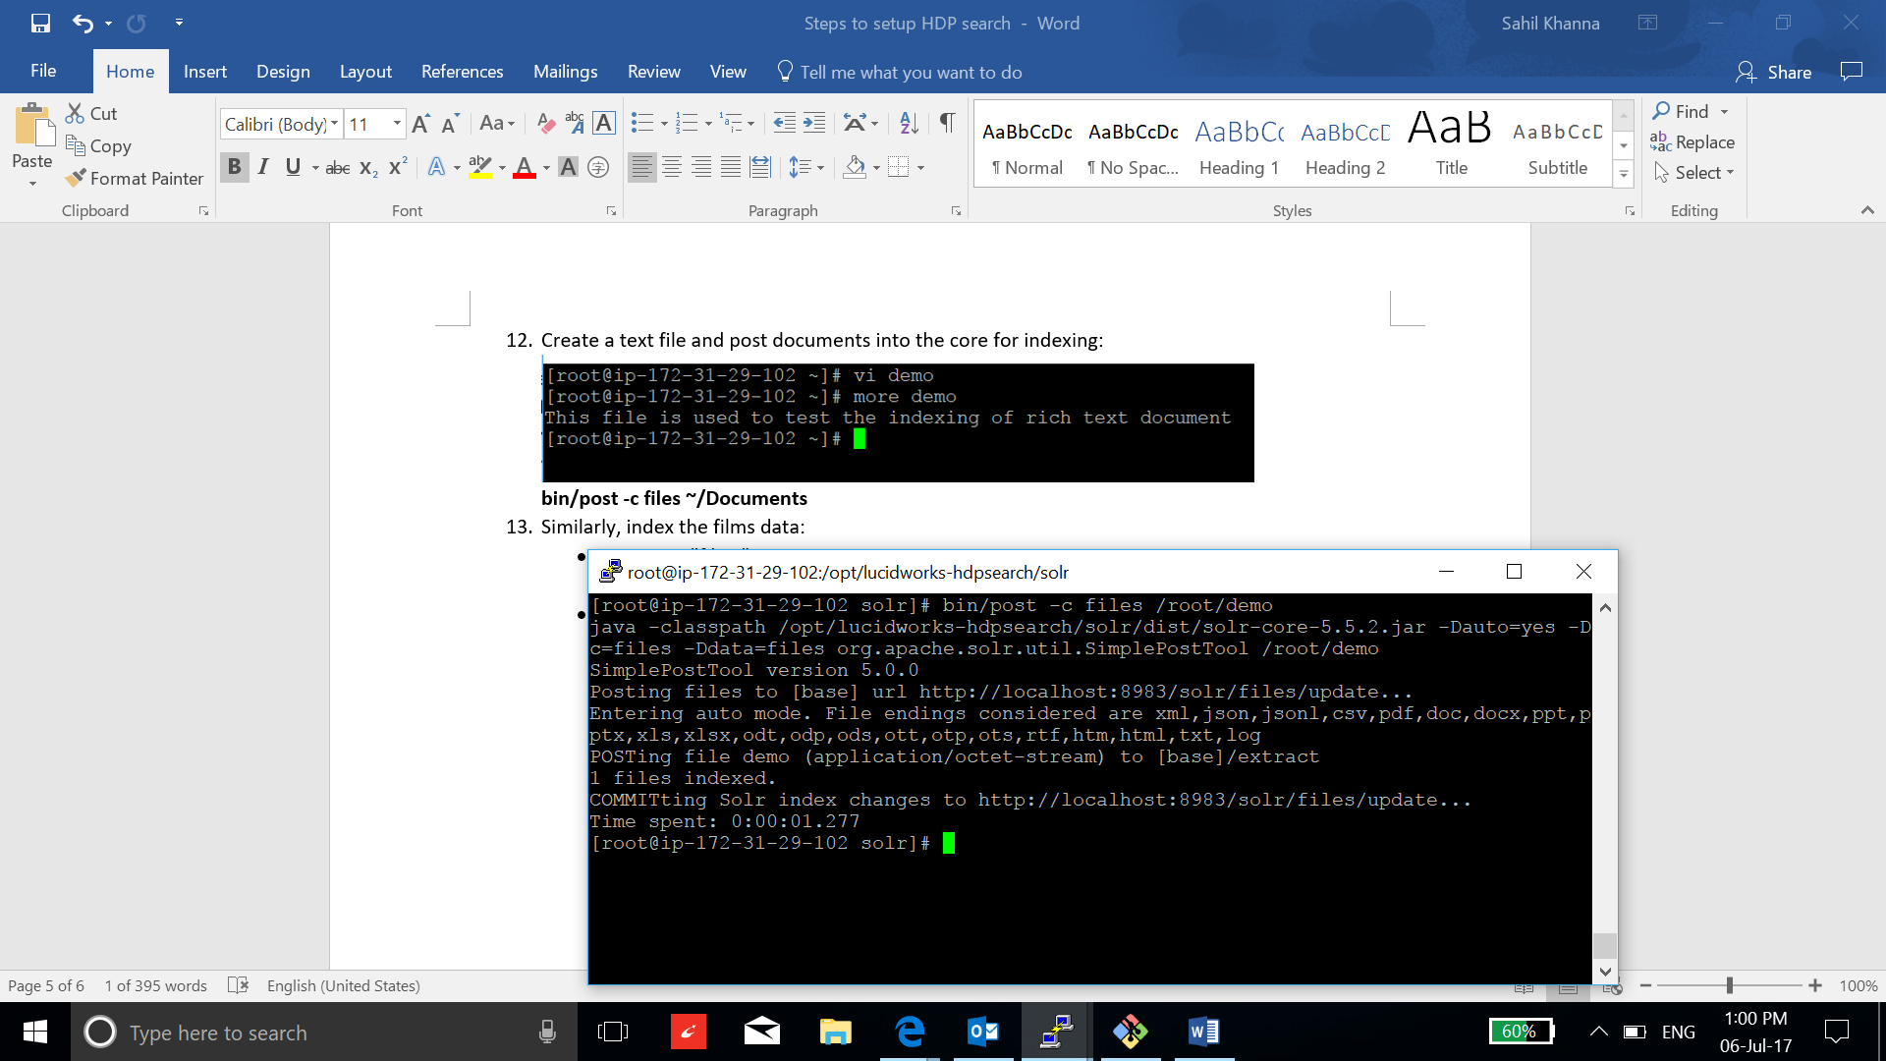

1. Verify the indexing:

* Go to Solr dashboard.
* Select the collection.
* Go to query
* Search any key

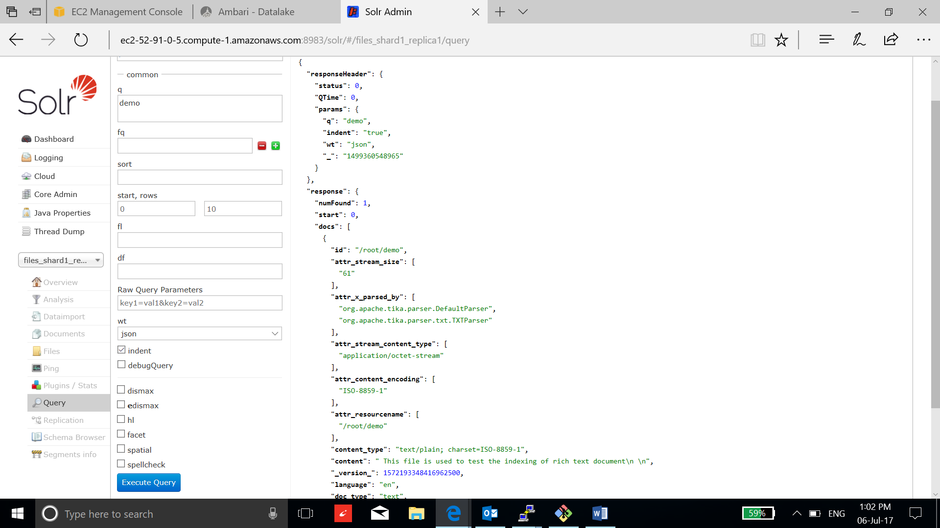

1. Similarly, index the films data:

* Create a "films" core:

**bin/solr create -c films**

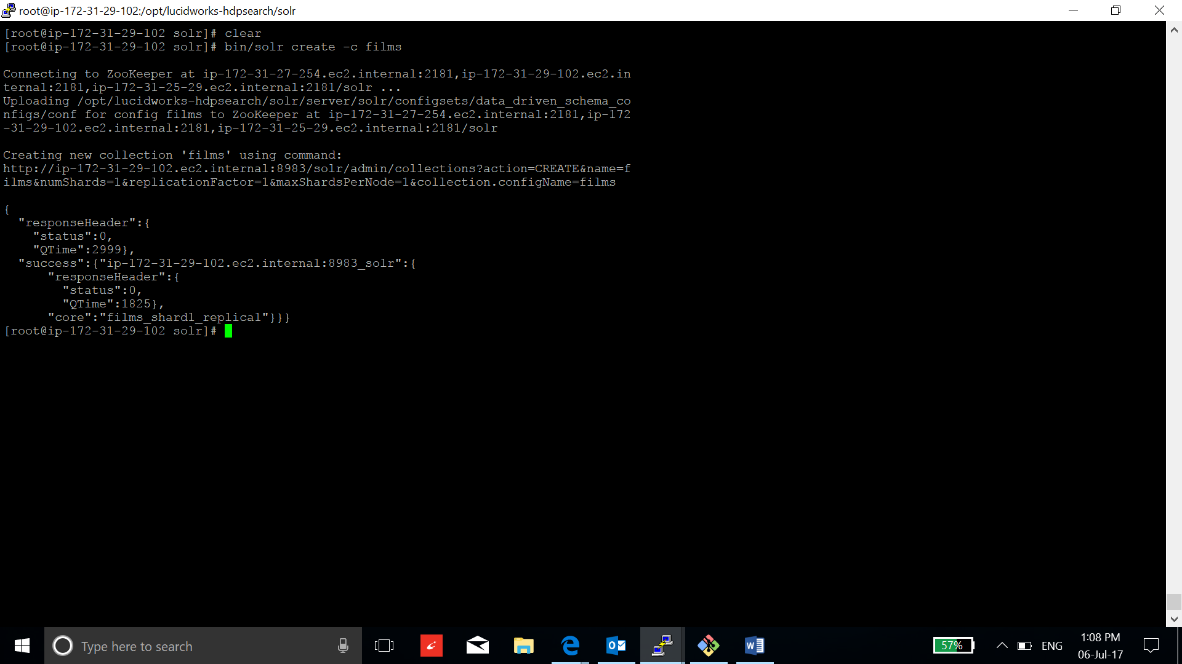

* Set the schema on a couple of fields that Solr would otherwise guess differently:

**curl http://localhost:8983/solr/films/schema -X POST -H 'Content-type:application/json' --data-binary '{**

**"add-field" : {**

**"name":"name",**

**"type":"text_general",**

**"multiValued":false,**

**"stored":true**

**},**

**"add-field" : {**

**"name":"initial_release_date",**

**"type":"tdate",**

**"stored":true**

**}**

**}'**

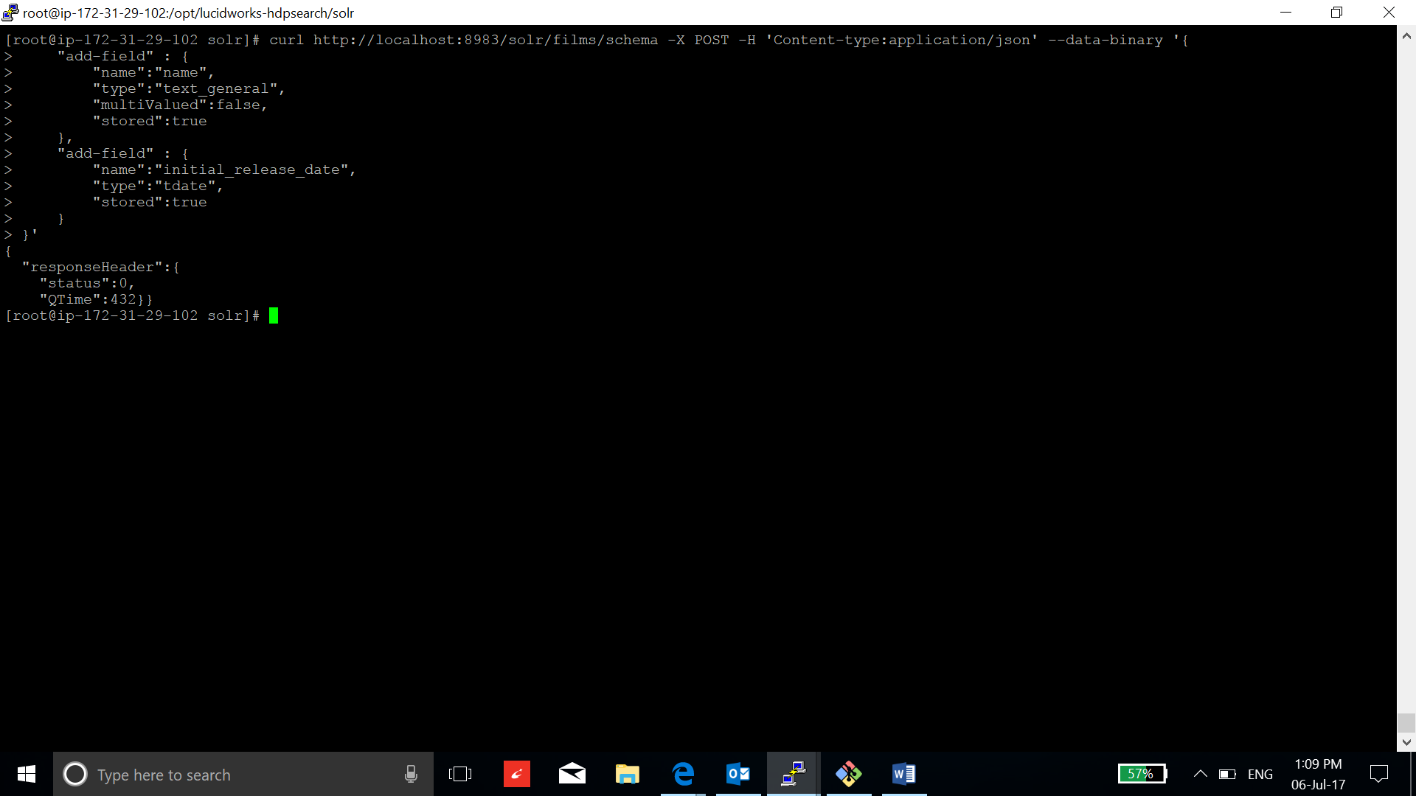

* Now let's index the data, using one of these three commands:

**- JSON: bin/post -c films example/films/films.json**

**- XML: bin/post -c films example/films/films.xml**

**- CSV: bin/post \**

**-c films \**

**example/films/films.csv \**

**-params "f.genre.split=true&f.directed_by.split=true&f.genre.separator=|&f.directed_by.separator=|"**

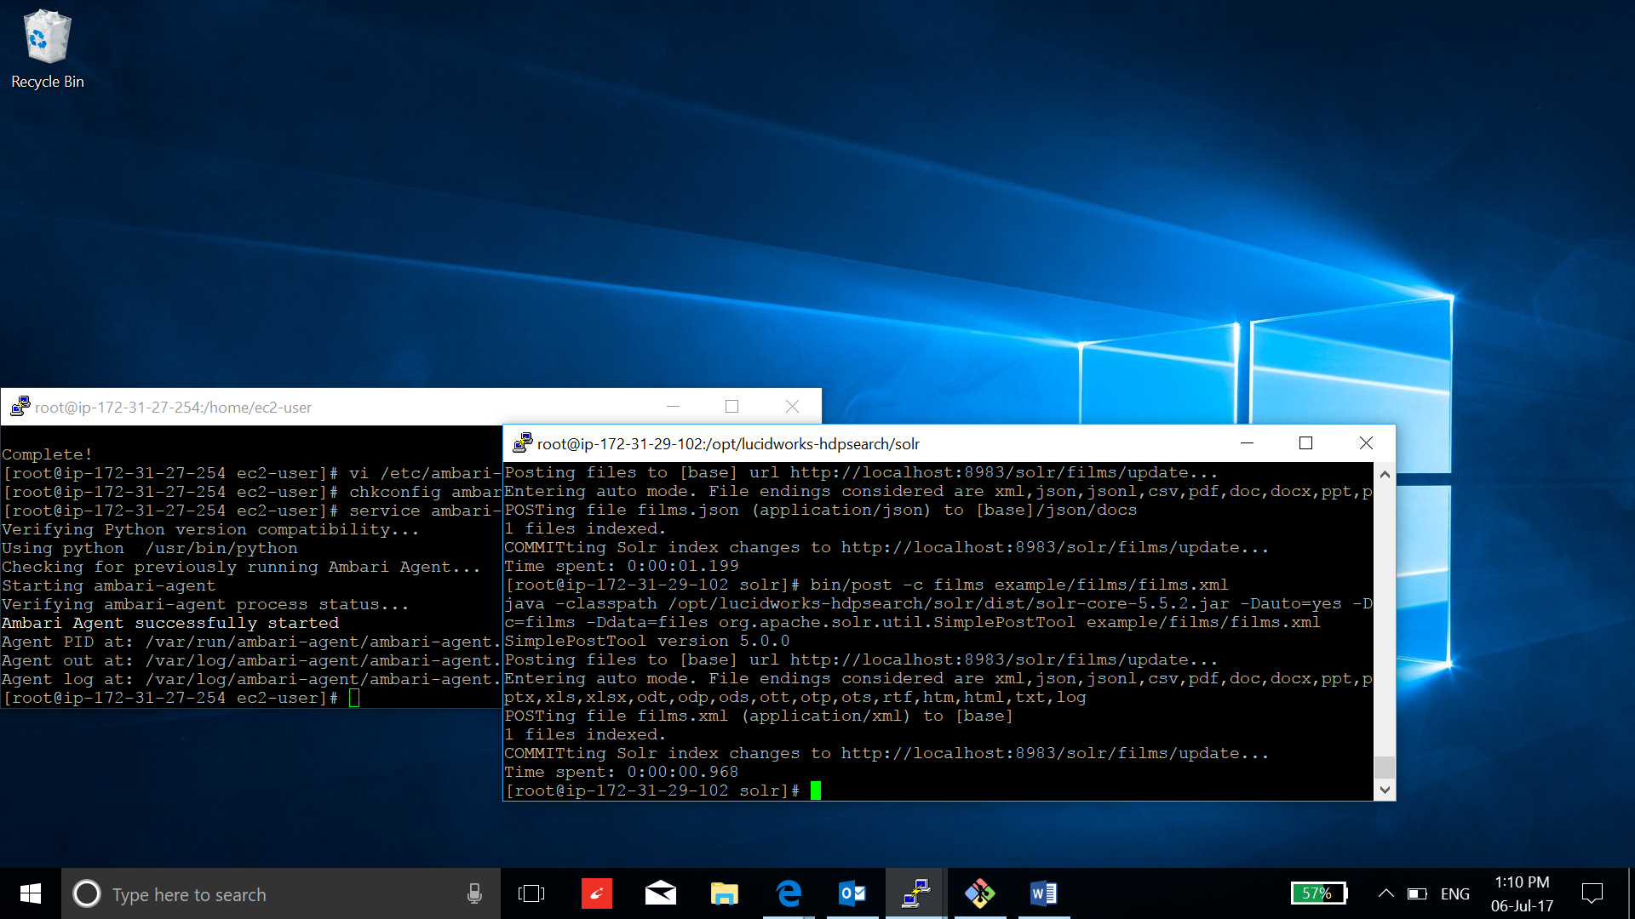

1. Run a query to verify:

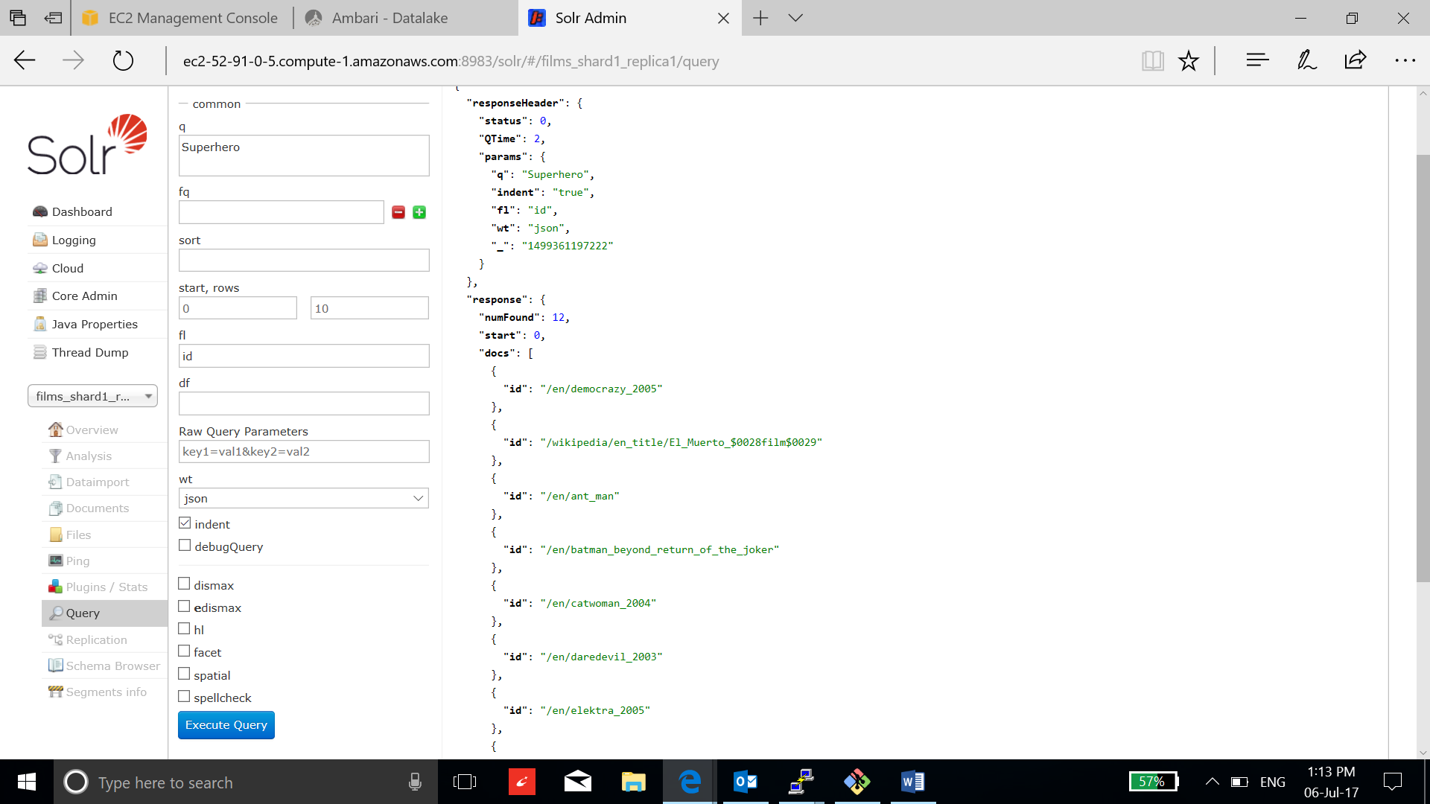

1. Run the Solr Data Import Handler example, do:

**Bin/solr stop -all**

**bin/solr -e dih**

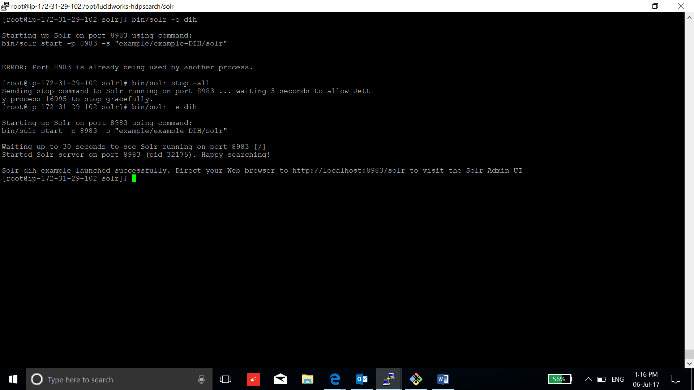

1. Go to Solr dashboard:

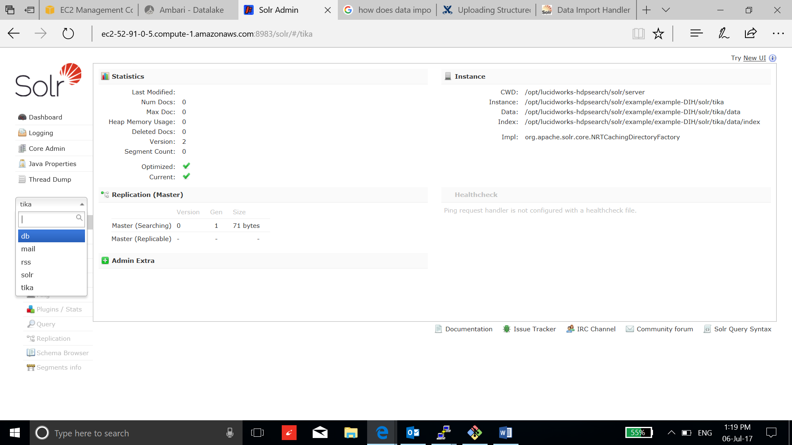

* To import data from the hsqldb database, connect to:

http://<public-DNS>:8983/solr/db/dataimport?command=full-import

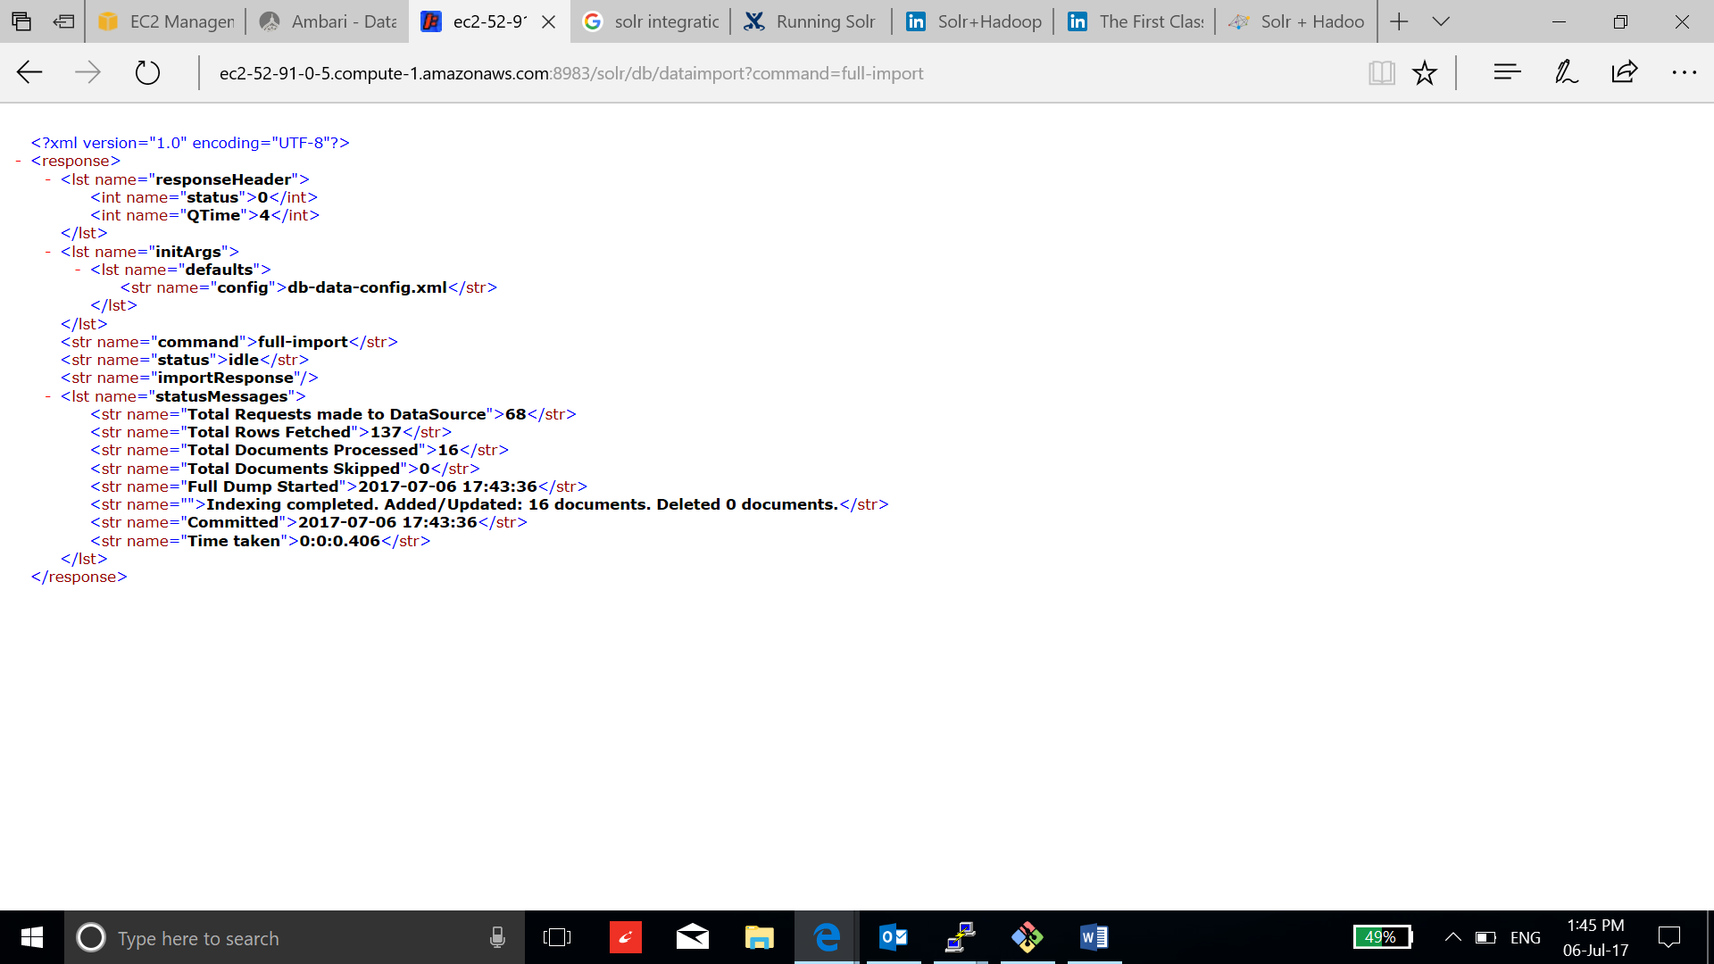

* To import data from an RSS feed, connect to:

http://<public-DNS>:8983/solr/rss/dataimport?command=full-import

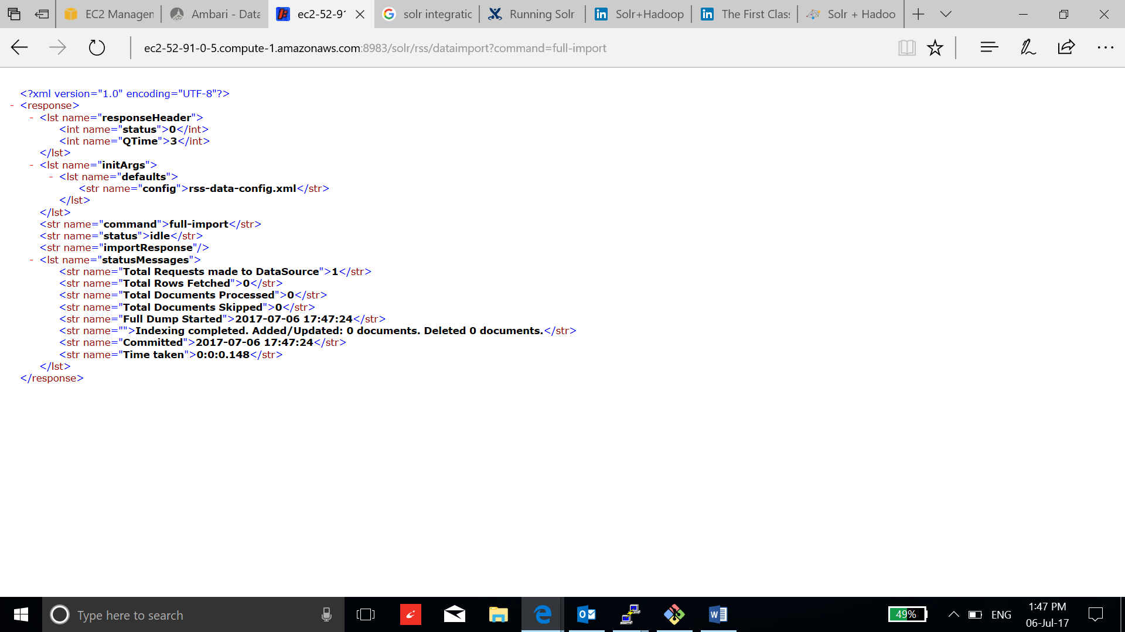

* To copy data from db Solr core, connect to:

http://<public-DNS>:8983/solr/solr/dataimport?command=full-import

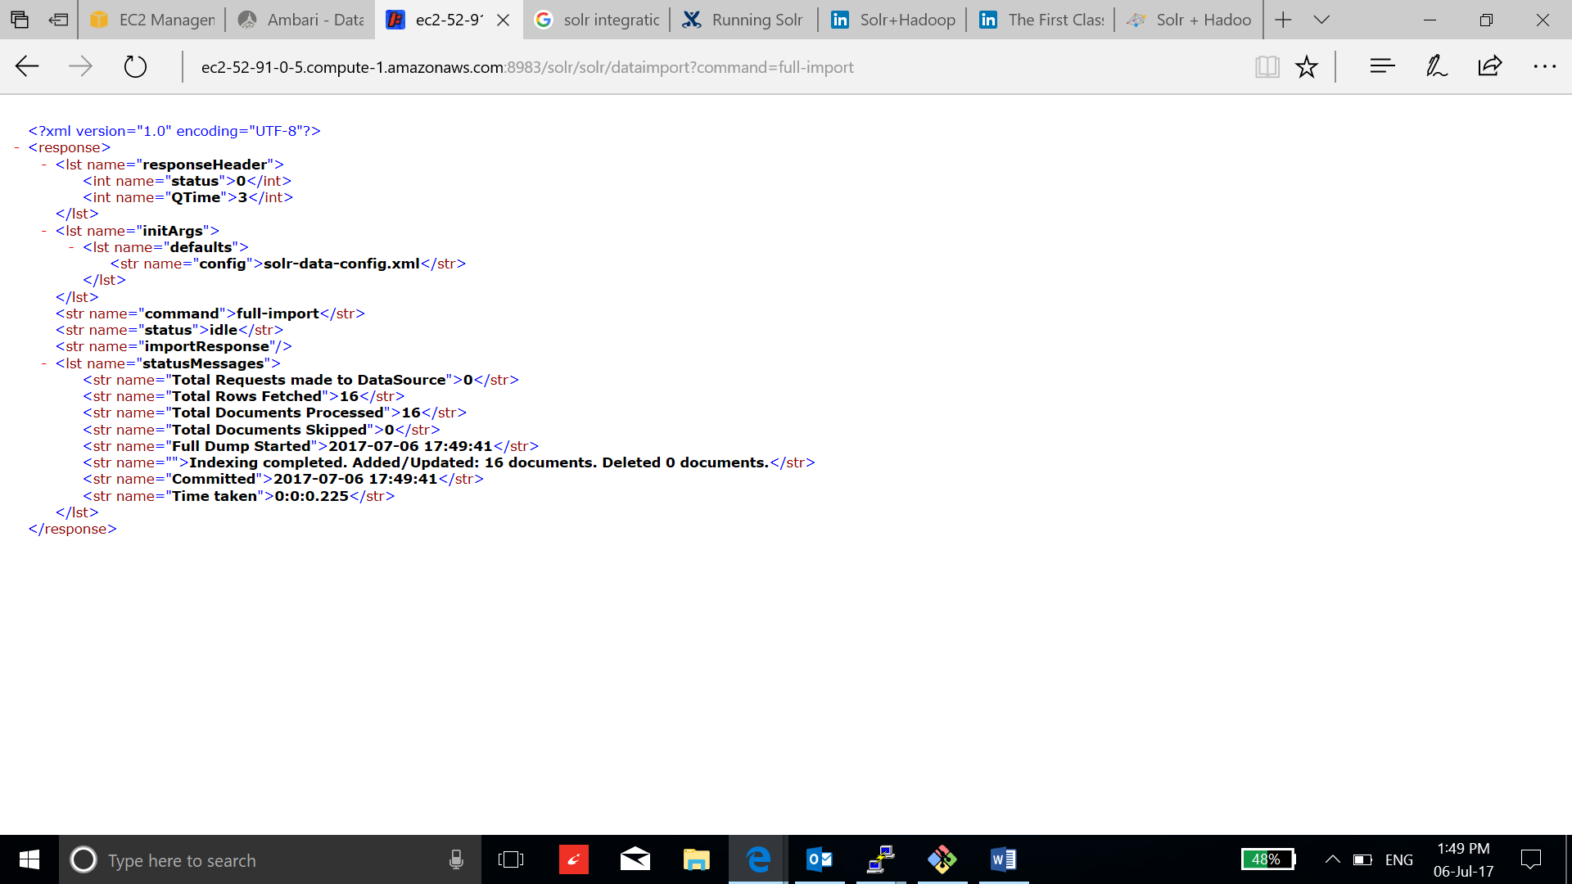

* To index a full text document using Tika integration:

http://<public-DNS>:8983/solr/tika/dataimport?command=full-import

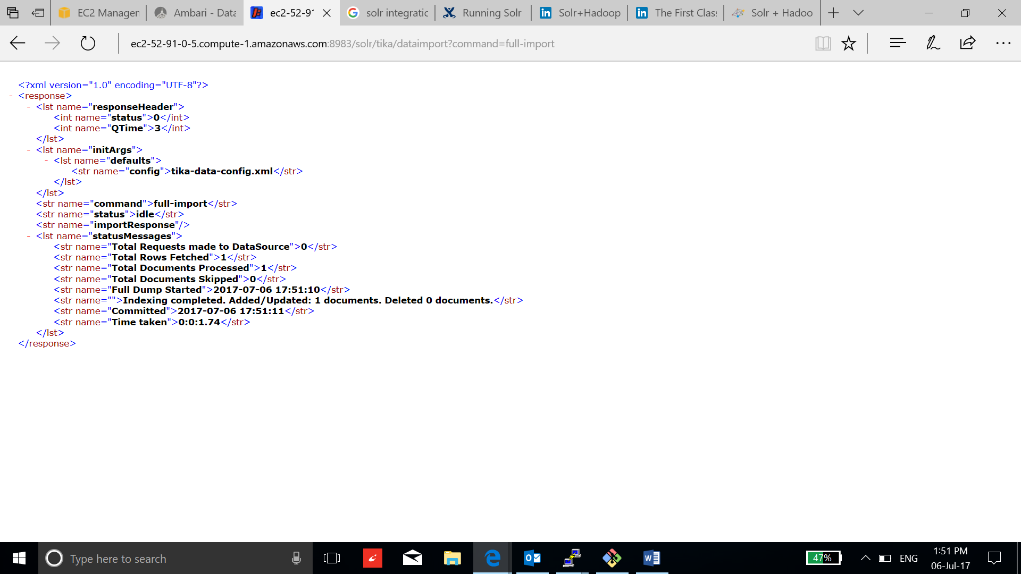

1. You can verify the import file on the Solr Dashboard:

